**Experiment No: 1**

|  |
| --- |
| **Student Name and Roll Number: Avtar Singh / 20csu241** |
| **Semester /Section: 5th / FSB** |
| **Link to Code:** |
| **Date: 8/3/2022** |
| **Faculty Signature:** |
| **Marks:** |

|  |
| --- |
| **Objective(s):**  To familiarize the students to Linux interface. |
| **Outcome:**   * The students will understand commands used in Linux. |
| **Problem Statement:**  Implement the following things:   * Cygwin Installation * Basic Linux commands |
| **Background Study:**  Cygwin is a open source tool which provides that functionality of the Linux in windows Operating System. Cygwin is a large collection of GNU and Open Source tools which provide functionality similar to a [Linux distribution](https://en.wikipedia.org/wiki/Linux_distribution) on Windows. It is a DLL (cygwin1.dll) which provides substantial POSIX API functionality. |
| **Question Bank:**   1. **What is Linux?** 2. How will you List files from a directory? 3. How files in a directory can be removed? 4. How to find out a word in a file? 5. What are wildcards? |

**Student Work Area**

**Algorithm/Flowchart/Code/Sample Outputs**

**Commands :**

**1.** **uname => Displays Linux system information**

**2. uname -r => Displays kernel release information**

**3. uptime => Displays how long the system has been running including load average**

**4. hostname => Shows the system hostname**

**5. hostname -i => Displays the IP address of the system**

**6. last reboot => Shows system reboot history**

**7. date => Displays current system date and time**

**8. timedatectl => Query and change the System clock**

**9. cal => Displays the current calendar month and day**

**10. w => Displays currently logged in users in the system**

**11. whoami => Displays who you are logged in as**

**12. finger username => Displays information about the user**

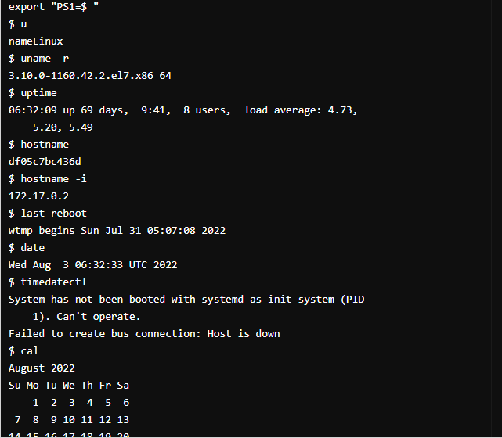

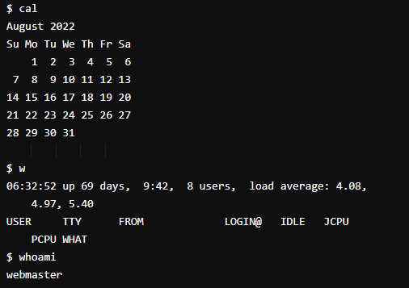

**Hardware**

**13. dmesg => Displays bootup messages**

**14.cat /proc/cpuinfo => Displays more information about CPU e.g model, model**

**name, cores, vendor id**

**15 .cat /proc/meminfo => Displays more information about hardware memory e.g.**

**Total and Free memory**

**16. lshw => Displays information about system’s hardware configuration**

**17. lsblk => Displays block devices related information**

**18. free -m => Displays free and used memory in the system (-m flag**

**indicates memory in MB)**

**19. lspci -tv => Displays PCI devices in a tree-like diagram**

**20. lsusb -tv => Displays USB devices in a tree-like diagram**

**21. dmidecode => Displays hardware information from the BIOS**

**22. hdparm -i /dev/xda => Displays information about disk data**

**23. hdparm -tT /dev/xda => Conducts a read speed test on device xda**

**24. badblocks -s /dev/xda => Tests for unreadable blocks on disk**

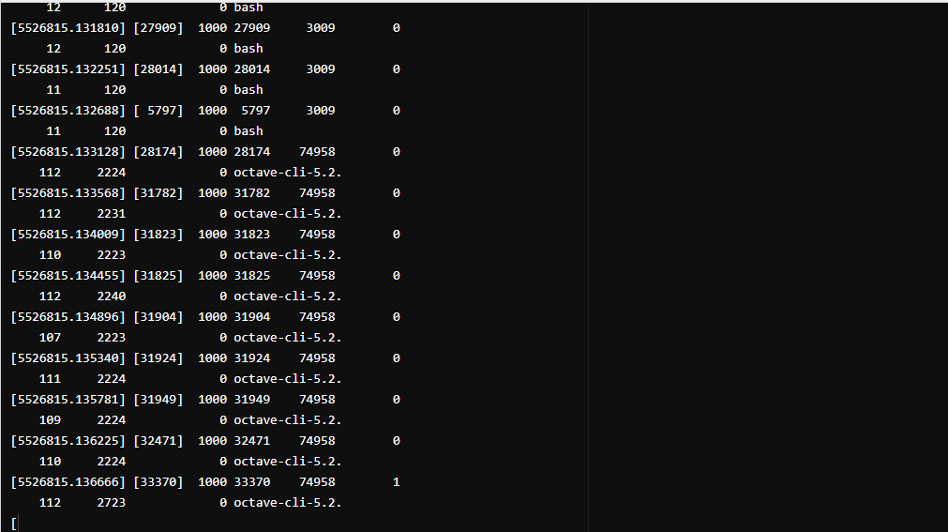

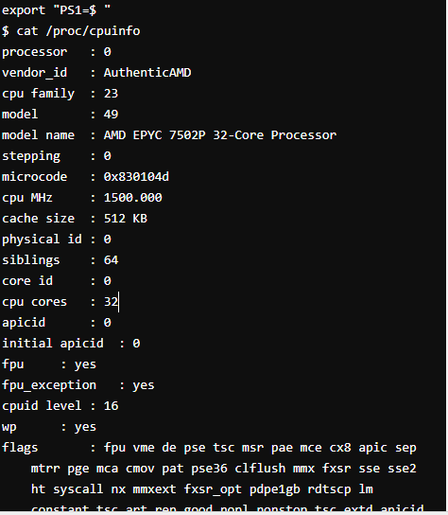

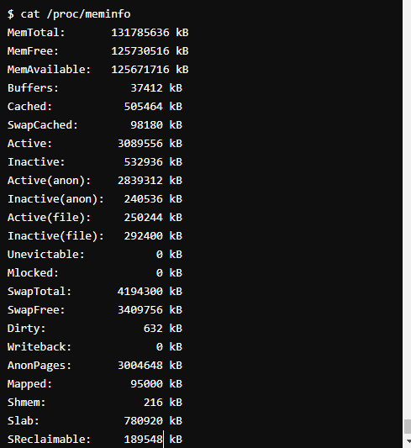

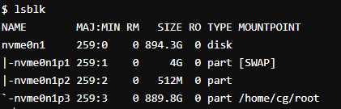

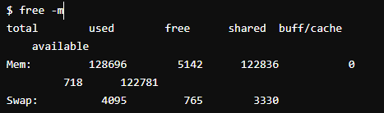

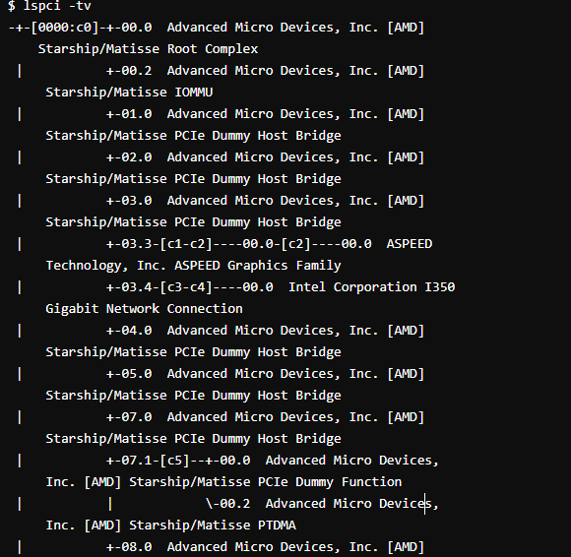

**User**

**1. id => Displays the details of the active user e.g. uid, gid, and**

**groups**

**2. last => Shows the last logins in the system**

**3.who => Shows who is logged in to the system**

**4. groupadd “admin” => Adds the group ‘admin’**

**5. adduser “Sam” => Adds user Sam**

**6. userdel “Sam” => Deletes user Sam**

**7. usermod => Used for changing / modifying user information**

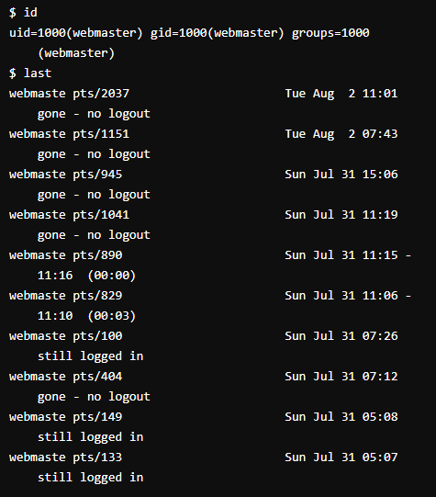

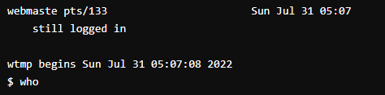

**File Commands**

1. **ls -al => Lists files - both regular & hidden files and their permissions as well.**
2. **pwd => Displays the current directory file path**
3. **mkdir ‘directory_name’ => Creates a new directory**
4. **rm file_name => Removes a file**
5. **rm -f filename => Forcefully removes a file**
6. **rm -r directory_name => Removes a directory recursively**
7. **rm -rf directory_name => Removes a directory forcefully and recursively**
8. **cp file1 file2 => Copies the contents of file1 to file2**
9. **cp -r dir1 dir2 => Recursively Copies dir1 to dir2. dir2 is created if it does not**

**exist**

1. **mv file1 file2 => Renames file1 to file2**
2. **ln -s /path/to/file_name**
3. **link_name**
   * **Creates a symbolic link to file_name**
4. **touch file_name => Creates a new file**
5. **cat > file_name => Places standard input into a file**
6. **more file_name => Outputs the contents of a file**
7. **head file_name => Displays the first 10 lines of a file**
8. **tail file_name => Displays the last 10 lines of a file**
9. **gpg -c file_name => Encrypts a file**
10. **gpg file_name.gpg => Decrypts a file**
11. **wc => Prints the number of bytes, words and lines in a file**
12. **xargs => Executes commands from standard input**

